**ASSIGNMENT 2**

**Aim**

Create the interactive webpages using JavaScript.

**Hardware Requirements**

The hardware requirements for designing a website using HTML, CSS and JavaScript properties will vary depending on the complexity of the website. However, some basic hardware requirements include a computer with **at least 1 GHz processor**, **1 GB of RAM**, and a **hard drive with at least 10 GB** of free space.

**Software Requirements**

**Text Editor**

|  |  |
| --- | --- |
| **Software** | **Version** |
| Notepad | 6.4 and above |
| Sublime text | 3 and above |
| VS Code | 1.46 and above |

**Web Browser**

|  |  |
| --- | --- |
| **Software** | **Version** |
| Chrome | 41 and above |
| Firefox | 52 and above |
| MS Edge | 79 and above |

**Knowledge Requirements**

* Knowledge of HTML, CSS and JavaScript.
* Understanding of web design principles
* Ability to use a text editor and a web browser

**Theory**

**Code & Output**

1. **Write a program to print hello world Code :**

<html>

<head>

<script type="text/javascript”>document.write("Hello World");

</script>

</head>

<body></body>

</html>

**Output:**

1. **Write a JavaScript to demonstrate user define function**

<html>

<head>

<script type="text/javascript">

function Hello(){

document.write("Hello World");

}

</script>

</head>

<body>

<input type="button" onclick="Hello()">

</body>

</html>

**Output**

1. **Write a JavaScript to demonstrate Operators**

<html>

<body>

<script type="text/javascript"> a=5; b=10; c=a+b;

document.write("a+b="+c);

</script>

</body> </html>

**Output**

1. **Write a JavaScript to demonstrate loop statement**

<html>

<body>

<script type="text/javascript">

i=0; do{

i++;

document.write(i+" ");

} while (i<10)

</script>

<br><br>

<script> i=0; while(i<10){ i++; document.write(i+" ")

}

</script>

<br><br>

<script> for(i=1;i<10;i++) document.write(i+" ")

</script>

</body>

</html>

**Output**

1. **Write a JavaScript to display alert pop up**

<html>

<head>

<title>Alert Box Example</title>

</head>

<body>

<button onclick="showAlert()">Click Me</button>

<script> function showAlert() { alert("This is an alert box!");

}

</script>

</body>

</html>

**Output**

1. **Write a JavaScript to get a prompt from user**

<html>

<head>

<title>Prompt Box Example</title>

</head> <body>

<button onclick="showPrompt()">Click Me</button>

<script> function showPrompt() { var userInput

= prompt("Please enter your name:"); if

(userInput !== null) { alert("Hello, " + userInput + "!");

} else { alert("You canceled the prompt.");

}

}

</script>

</body>

</html>

**Output**

1. **Write a JavaScript to display confirm pop up**

<html>

<head>

<title>Confirm Box Example</title>

</head>

<body>

<button onclick="showConfirm()">Click Me</button>

<script> function showConfirm() { var result = confirm("Are you sure you want to delete this item?");

if (result) {

alert("Item deleted.");

} else {

alert("Deletion canceled.");

}

}

</script>

</body>

</html>

**Output**

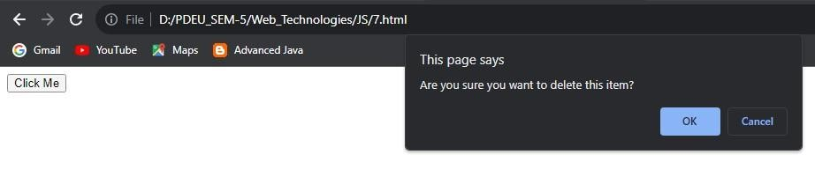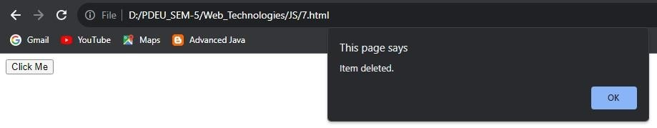

1. **Write a JavaScript to validate form input**

<!DOCTYPE html>

<html>

<head>

<title>Basic Form Validation</title>

</head>

<body>

<h2>Basic Form Validation</h2>

<form id="myForm">

<label for="name">Name:</label>

<input type="text" id="name" name="name"><br><br>

<label for="email">Email:</label>

<input type="email" id="email" name="email"><br><br>

<input type="submit" value="Submit">

</form>

<p id="error" style="color: red;"></p>

<script> var form = document.getElementById('myForm'); form.addEventListener('submit', function (event) { event.preventDefault();

var name = document.getElementById('name').value;

var email = document.getElementById('email').value;

if (name === '' || email === '') {

document.getElementById('error').textContent = 'Both fields are required!

} else {

document.getElementById('error').textContent = ''; alert('Form submitted successfully!'); form.reset();

}

});

</script>

</body>

</html>

**Output**

**Conclusion**

* In conclusion, acquiring a fundamental understanding of JavaScript provides a solid foundation for web development and opens the door to creating dynamic and interactive web applications.
* Further exploration and practice in this versatile language will undoubtedly enhance one's coding skills and career opportunities.

**References**

* W3 School JavaScript Tutorial : <https://www.w3schools.com/js/>
* Javatpoint JS Tutorial: [https://www.javatpoint.com/javascripttutorial](https://www.javatpoint.com/javascript-tutorial)

**ASSIGNMENT 3**

**Aim**

Install LAMP Stack.

**Hardware Requirements**

The hardware requirements for designing a website using HTML, CSS and JavaScript properties will vary depending on the complexity of the website. However, some basic hardware requirements include a computer with **at least 1 GHz processor**, **1 GB of RAM**, and a **hard drive with at least 10 GB** of free space.

**Software Requirements**

**Text Editor**

|  |  |
| --- | --- |
| **Software** | **Version** |
| Notepad | 6.4 and above |
| Sublime text | 3 and above |
| VS Code | 1.46 and above |

**Web Browser**

|  |  |
| --- | --- |
| **Software** | **Version** |
| Chrome | 41 and above |
| Firefox | 52 and above |
| MS Edge | 79 and above |

**Knowledge Requirements**

* Ability to use a text editor and a web browser

**Theory**

**Code & Output**

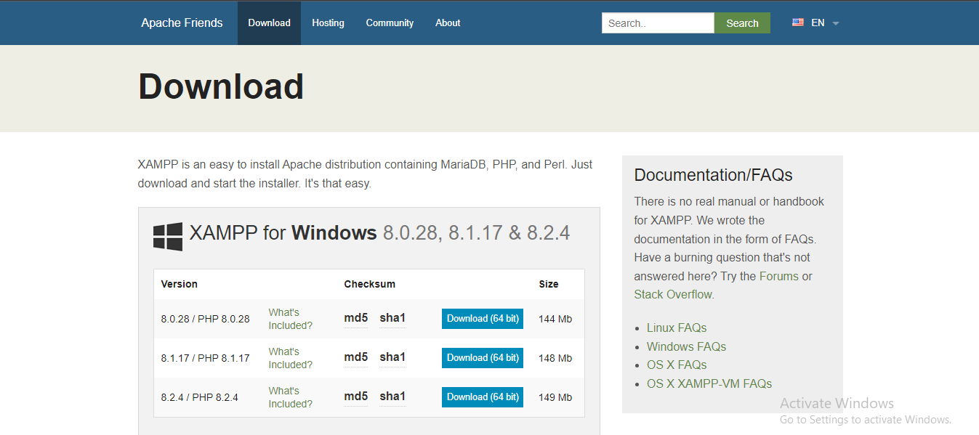

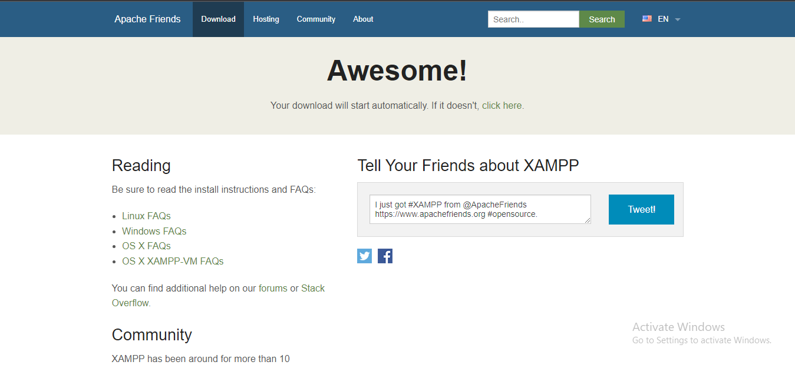

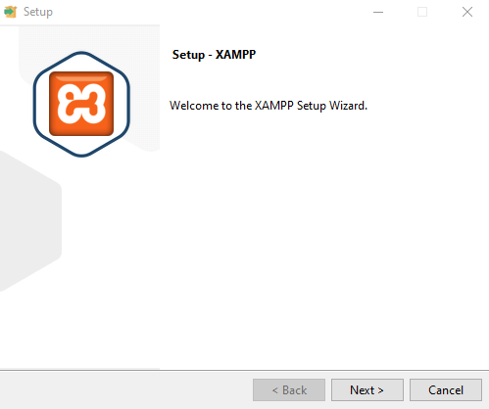



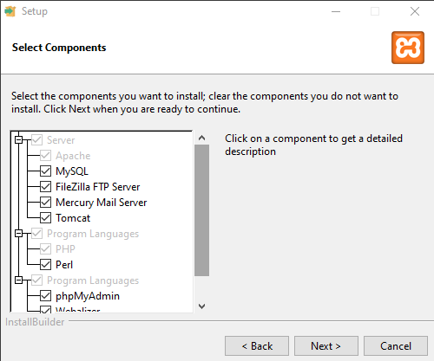

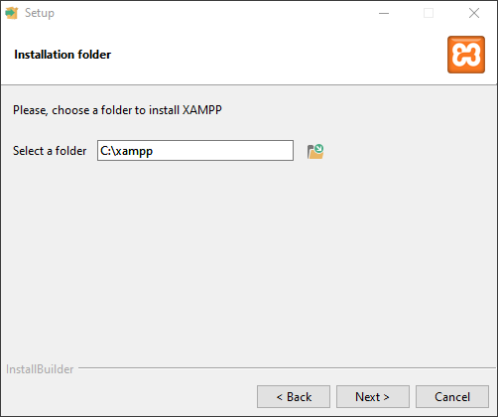

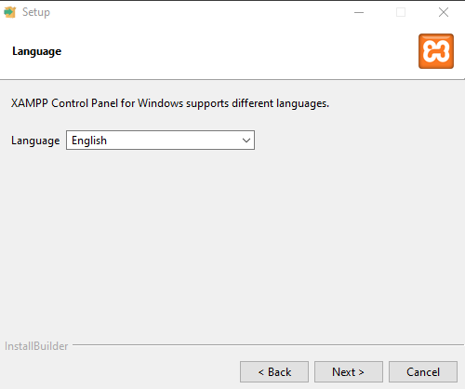

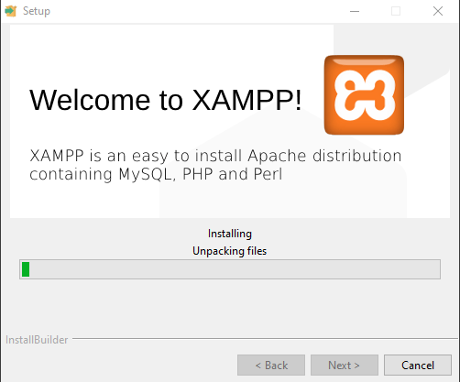



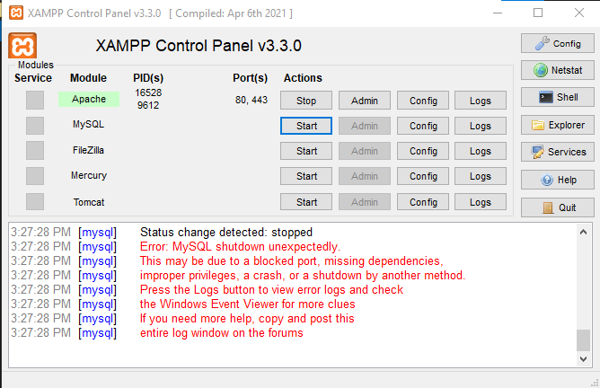

**Conclusion**

* In conclusion, acquiring a fundamental understanding of JavaScript provides a solid foundation for web development and opens the door to creating dynamic and interactive web applications.
* Further exploration and practice in this versatile language will undoubtedly enhance one's coding skills and career opportunities.

**References**

* W3 School JavaScript Tutorial : <https://www.w3schools.com/js/>
* Javatpoint JS Tutorial: [https://www.javatpoint.com/javascripttutorial](https://www.javatpoint.com/javascript-tutorial)